Create a directory called ""my_folder"", navigate into it

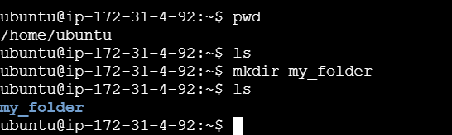

create a file named ""my_file.txt"" with some text

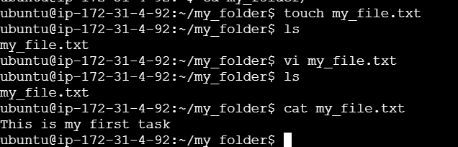

 Then, create another file named ""another_file.txt"" with some text.

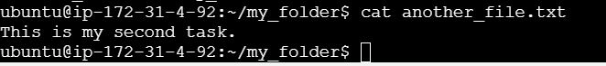

Concatenate the content of ""another_file.txt"" to ""my_file.txt"" and display the updated content

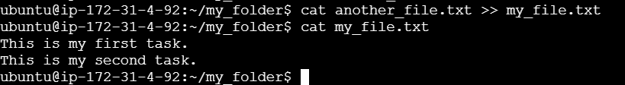

Finally, list all files and directories in the current directory

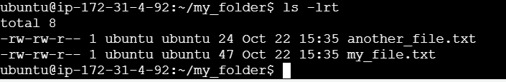

Create 20 files with .txt extensions



rename the first 5 files to .yml extension and Print the latest created top 5 files among the total no of files

